**DATA WAREHOUSING AND DATA MINING-LABORATORY**

**ASSIGNMENT – 1**

**Name**: Pranav mishra **REG NO**: 12114762

**ROLL NO**: **RDOC09A55** **Course Code**: CAP447

**Teacher**: Shilpa **Course Title**: Data Warehousing and Data Mining-Laboratory

**Q1. Perform the steps to import data from your local computer.**

**Answer:** To import data from local computer have following steps:

* Click on **Data Import Button**

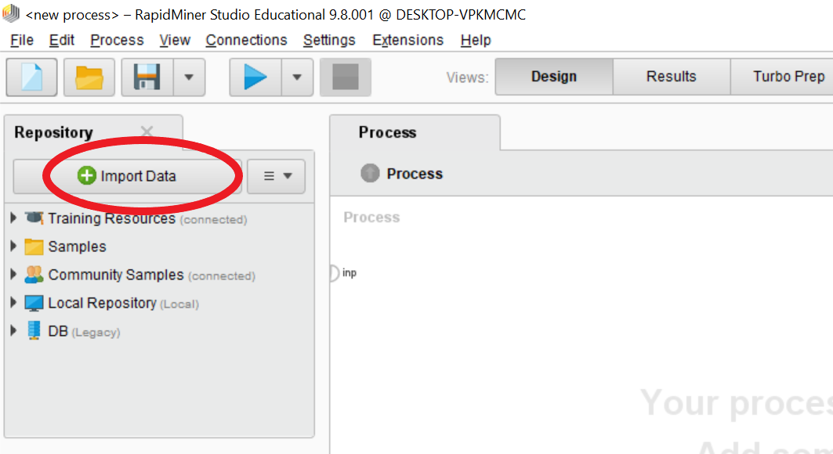

* Select from where you want to import data?

Select the **My Computer Button** and then select the data(file).

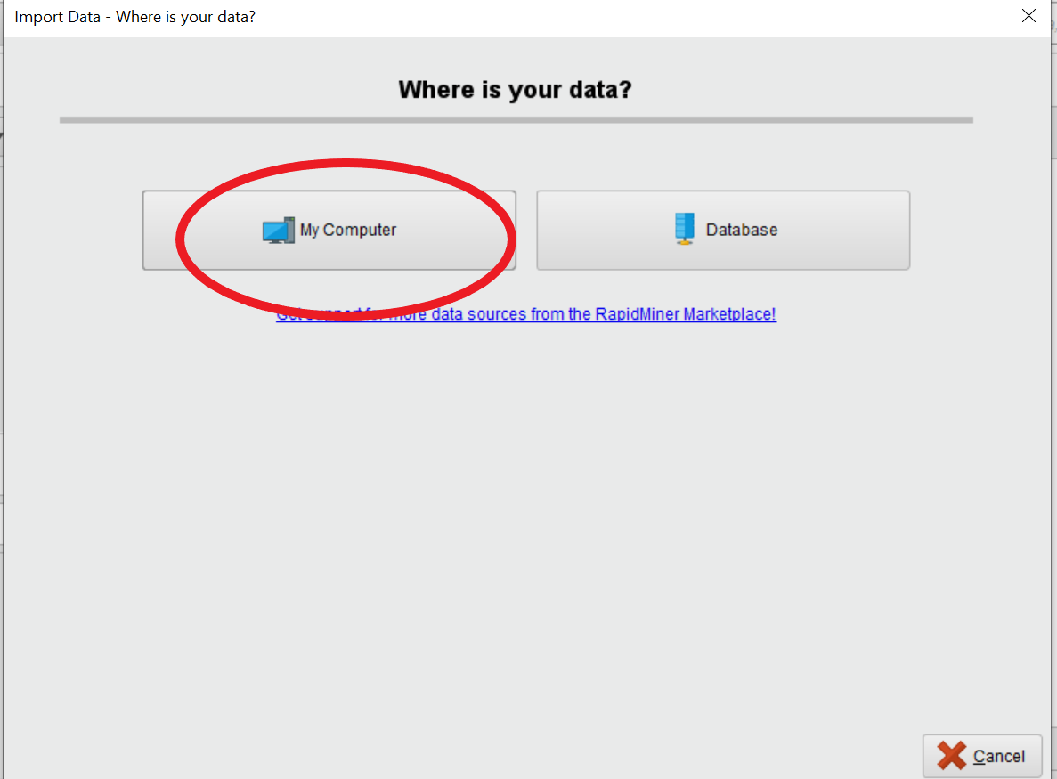

* Select the exact location of data (file) and then press 🡪**Next Button**

Here my data is present in **Downloads** and then press **Next Button.**

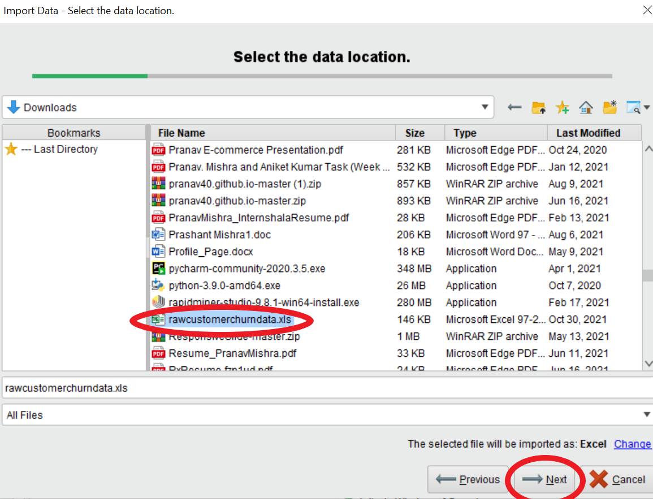

* Then it will ask to select cells which you want to import and click on **🡪Next Button**.

Here I select all cells from data(file) and then press to the **Next Button**.

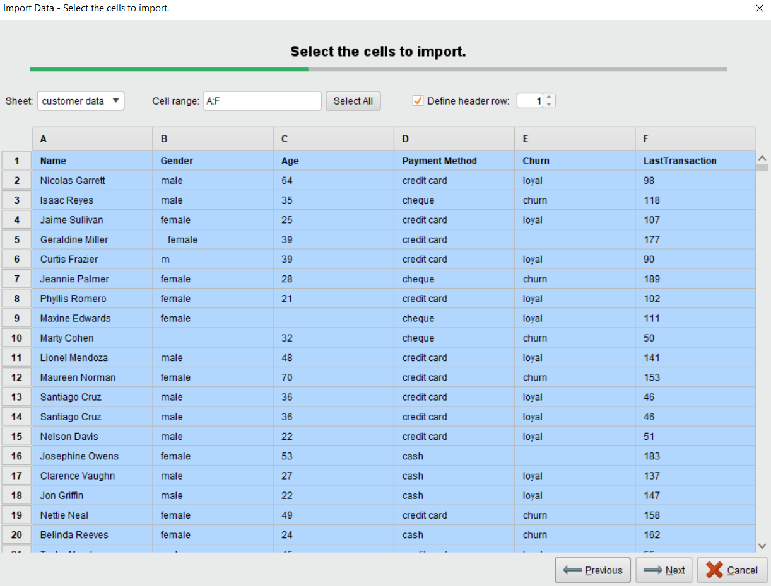

* Will ask to change the format of data. If you want to change the format of data then you can change it by click on setting icon after change the format of data just click on **🡪Next Button**

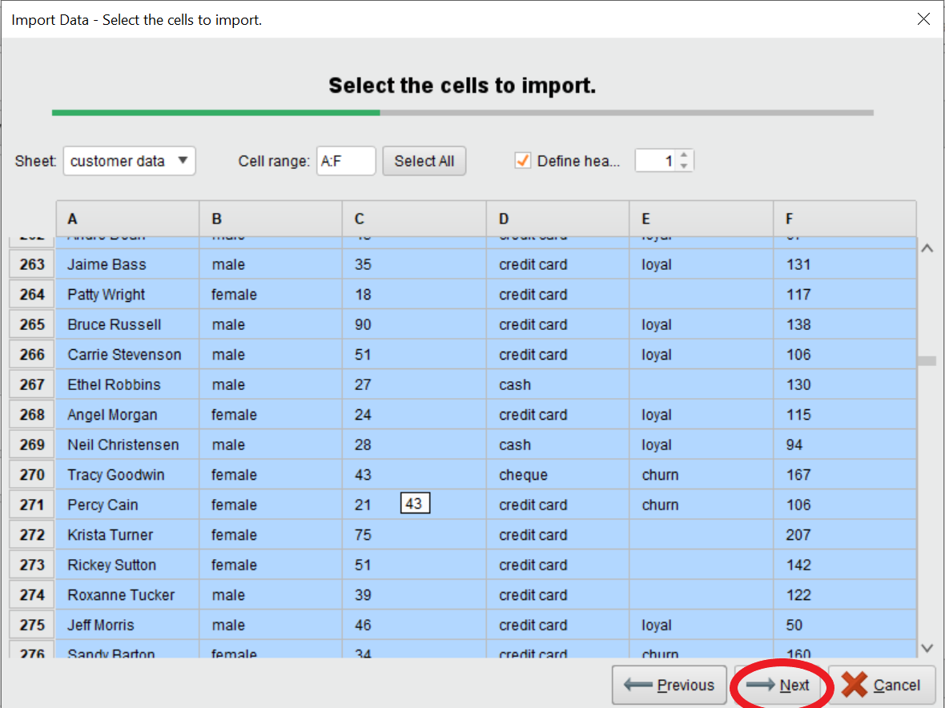

* Save your data(file) where you want to save, can change file name, after select the location click on **Finish button** and the save the data(file).

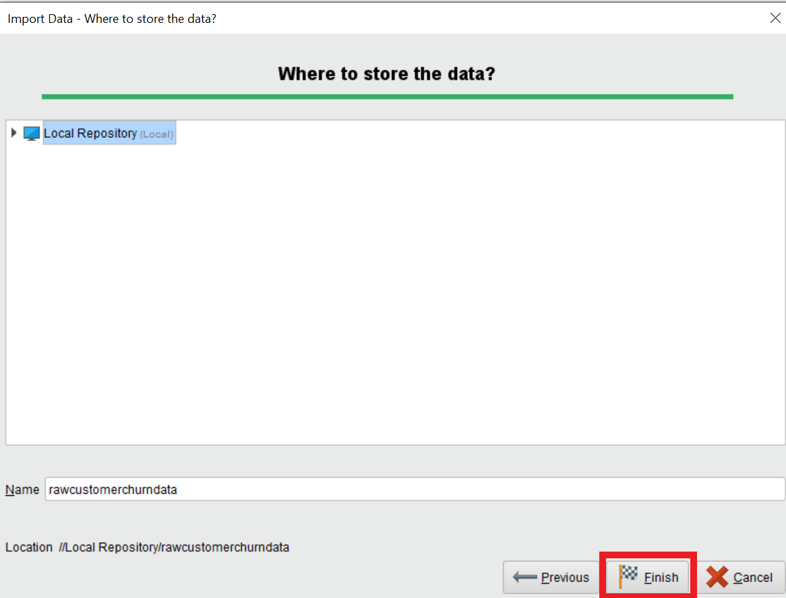

* Then you can see data is Successfully imported in **Local Repository** **folder** and select the data and drag and drop then perform the operation and execute the operation.

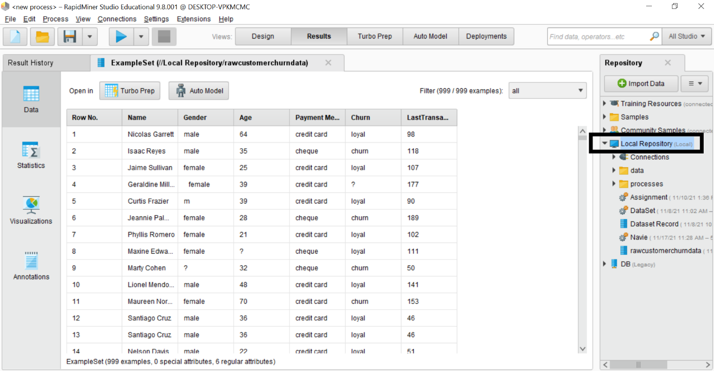

**Q2. Perform following operations on your data you imported.**

1. **Remove duplicates**

In our data there is many duplicates in Gender, Payment Method, Churn, Last Transaction etc.

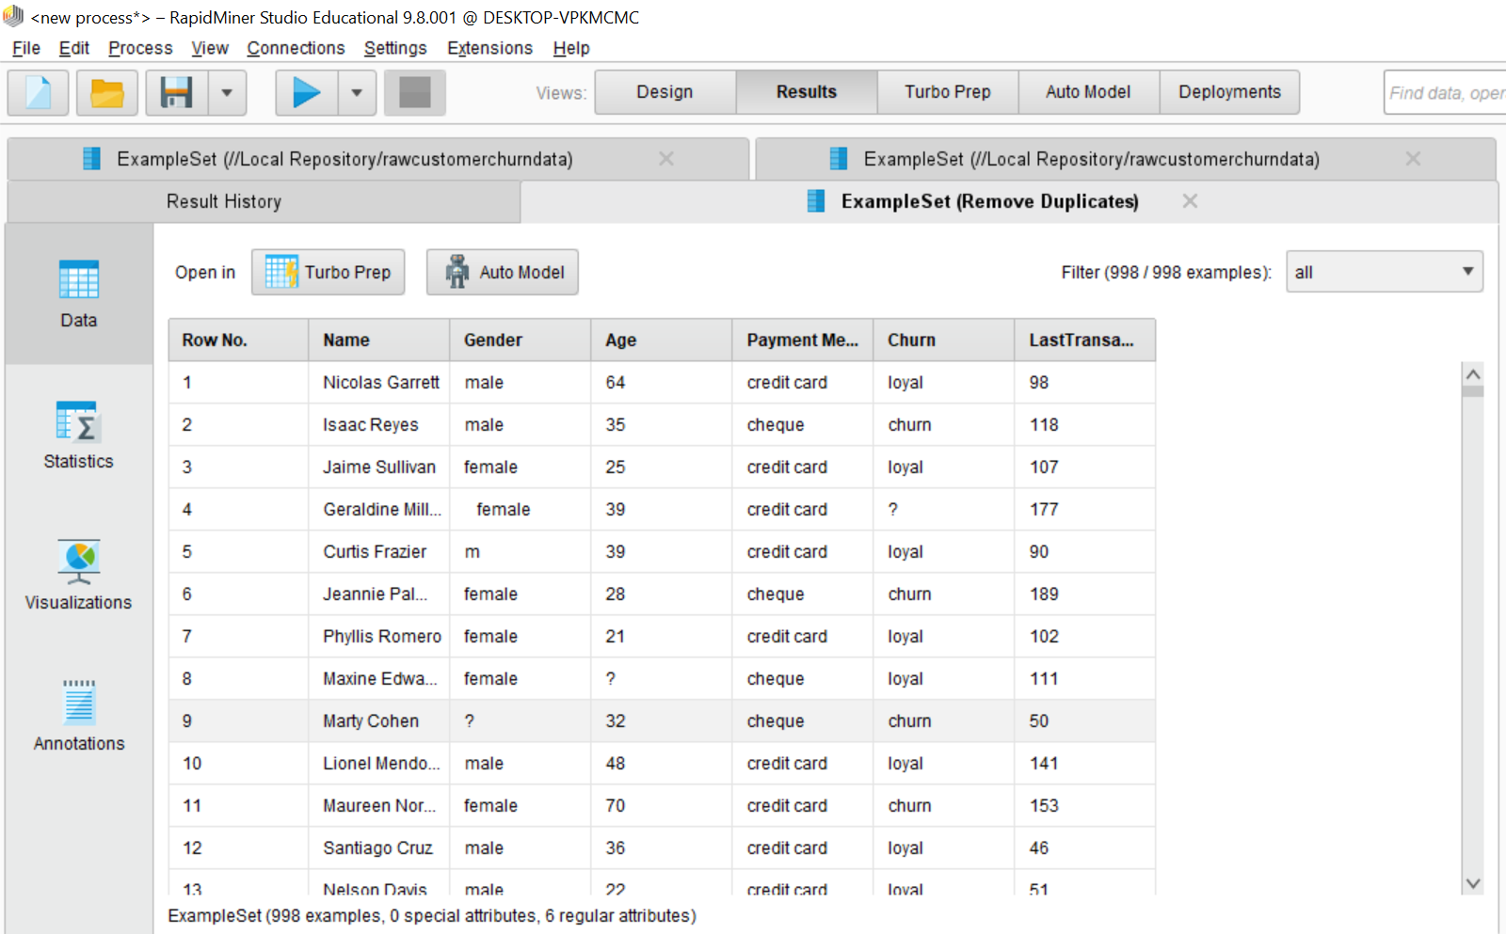

In parameters, select one attributes filter types to remove duplicates value from select attributes.

select the attribute **Payment** **Method**.

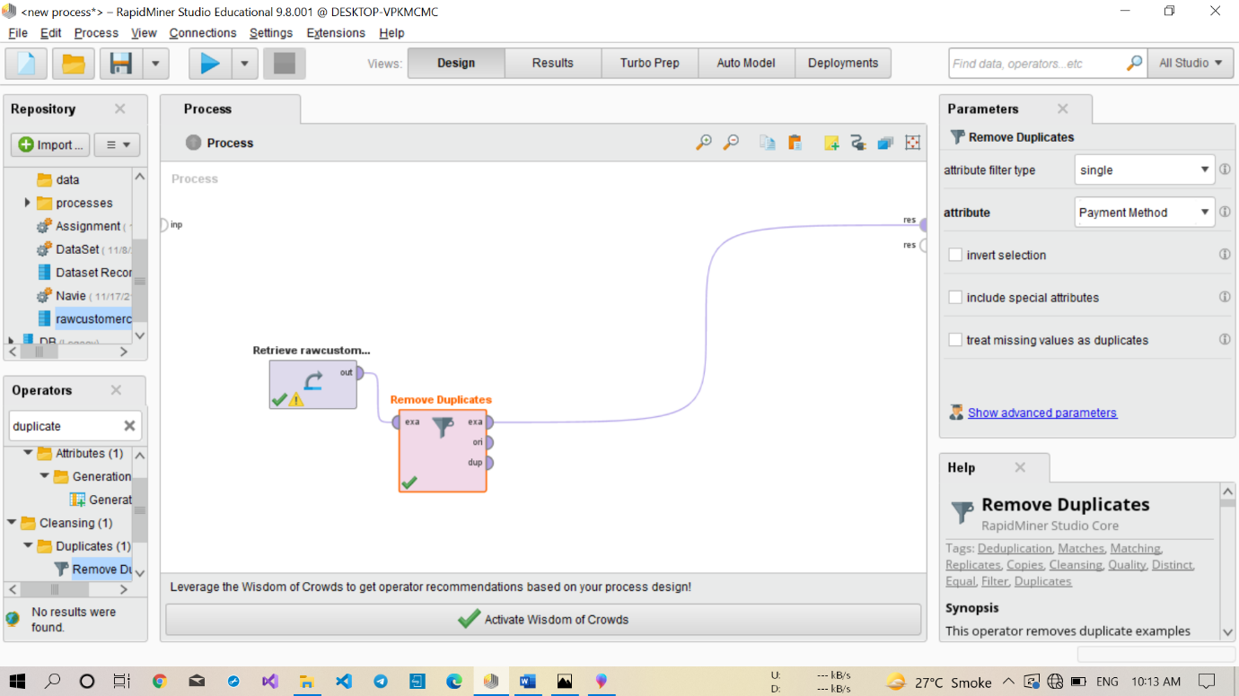

We can see in Payment Method all duplicate values removed.

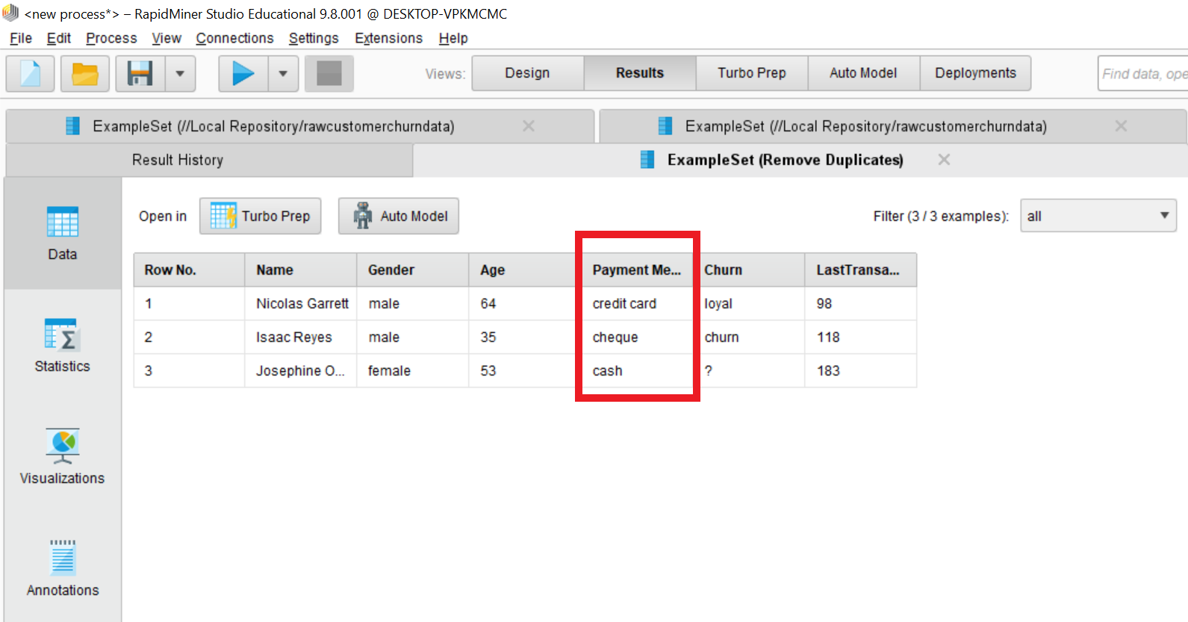

1. **Filter missing data**

Missing data is filtered by using filter **Examples** operator then execute the filter operation then see the result of missing value.

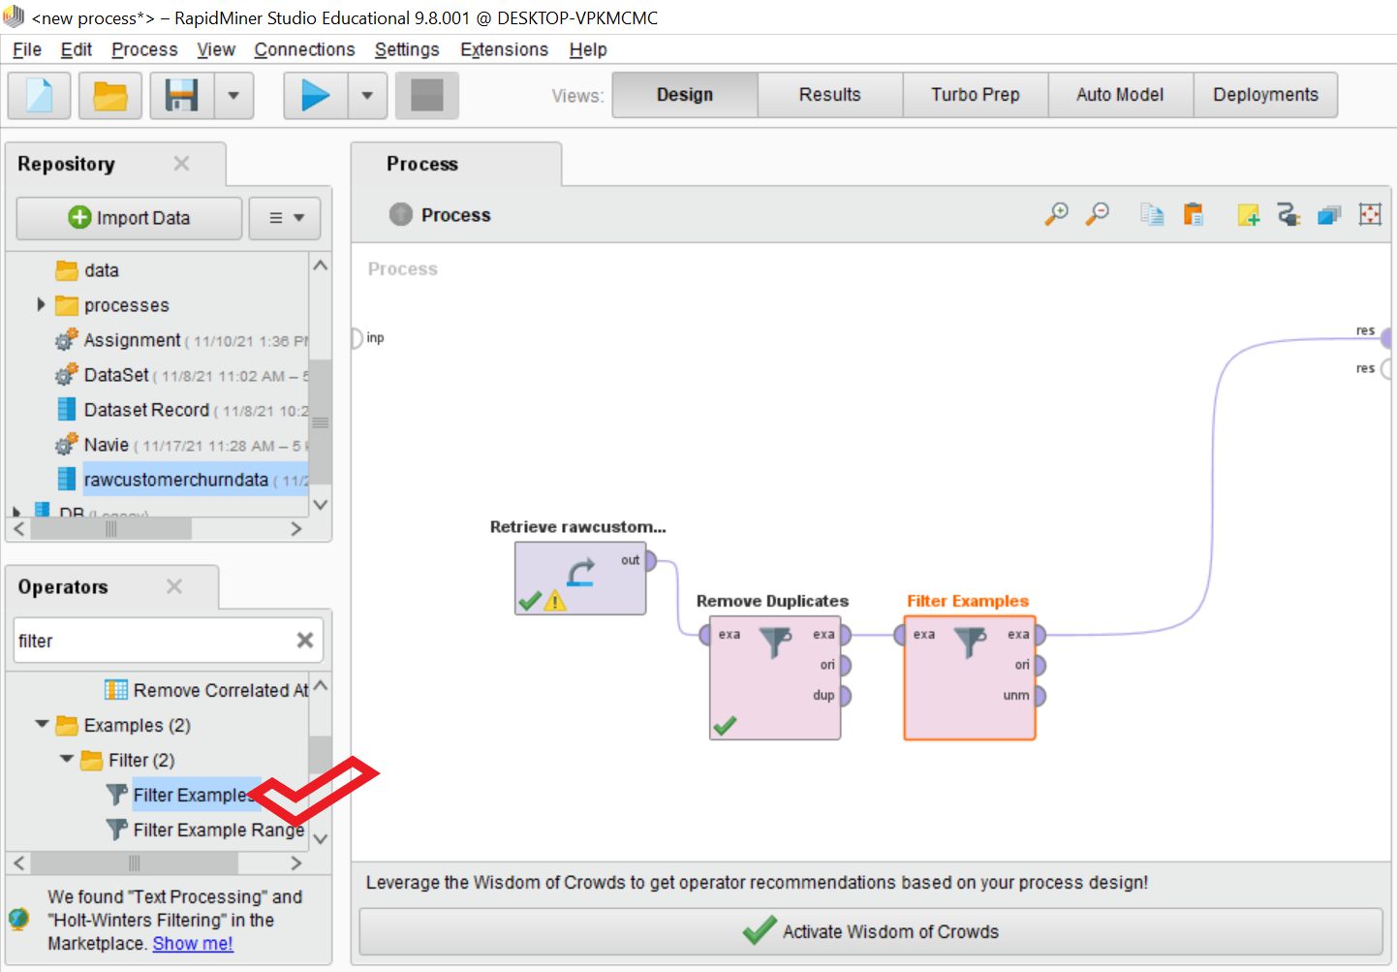

Here We can see there is three attributes I have select Gender, **Age** and **Churn** and perform the operation and got missing values in three attributes.

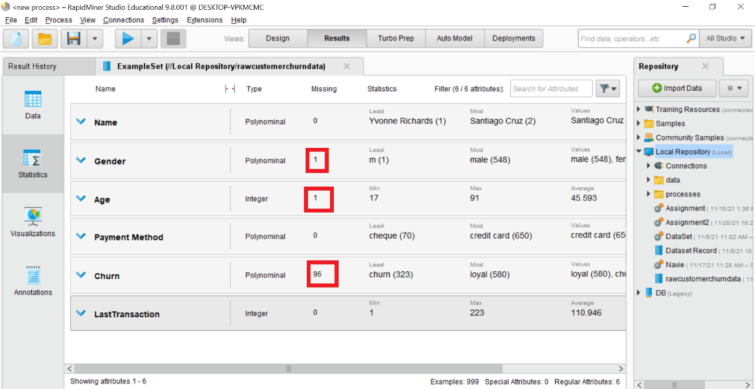

And then go to **Parameters**, then add attributes from which we want to filter missing values, after adding the attributes then go to the **OK Button** and press.

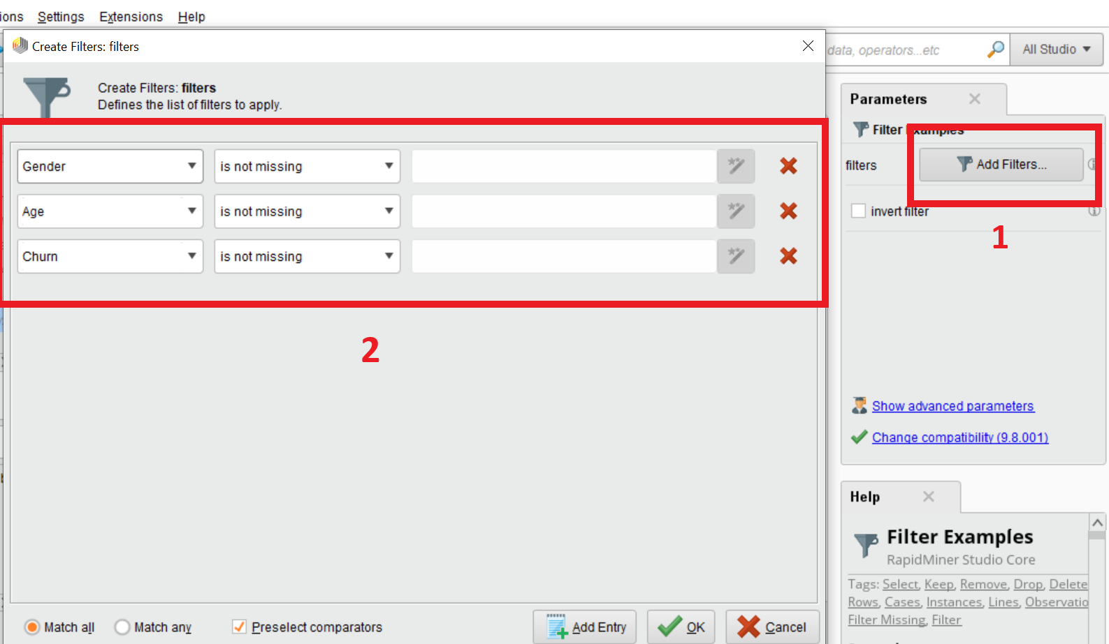

Now all the Missing values are filtered, data haven’t missing values in the selected above attributes **gender, age** and **churn**.

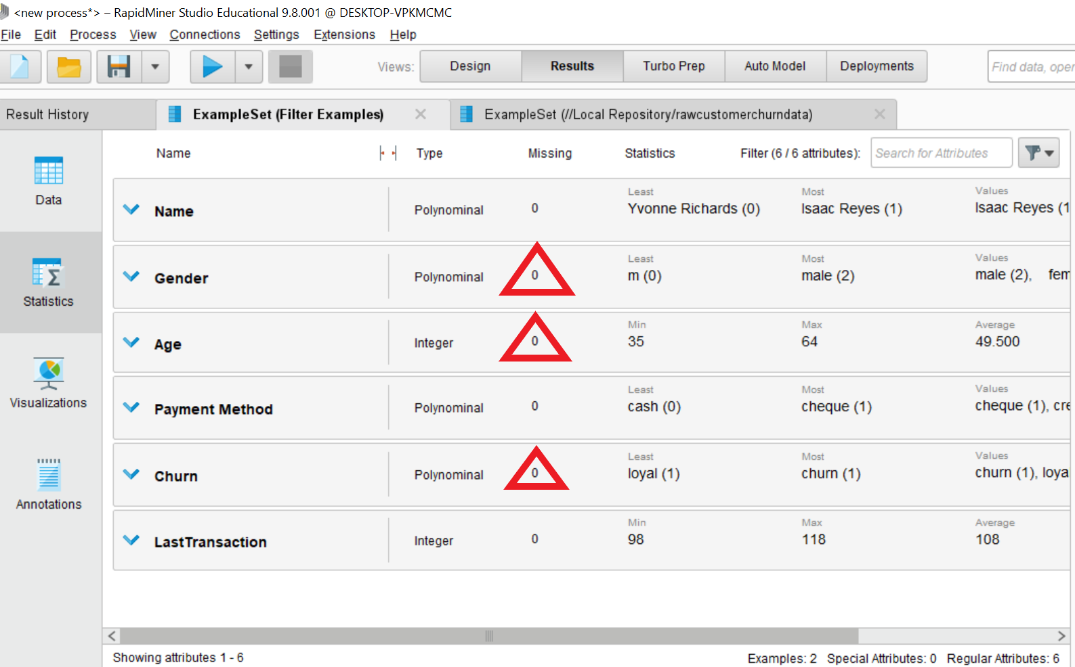

1. **Setting roles**

When we use Set Role operator, firstly we can drag and drop the set operator and then select the attributes name from parameter, after select attribute name we select the target role which you want to give specific role.

Here I drag and drop the **Set Role** **Operator** then go to parameter and select attribute name is **Payment Method** and then select the target role **Label** then I execute the operation and see the result.

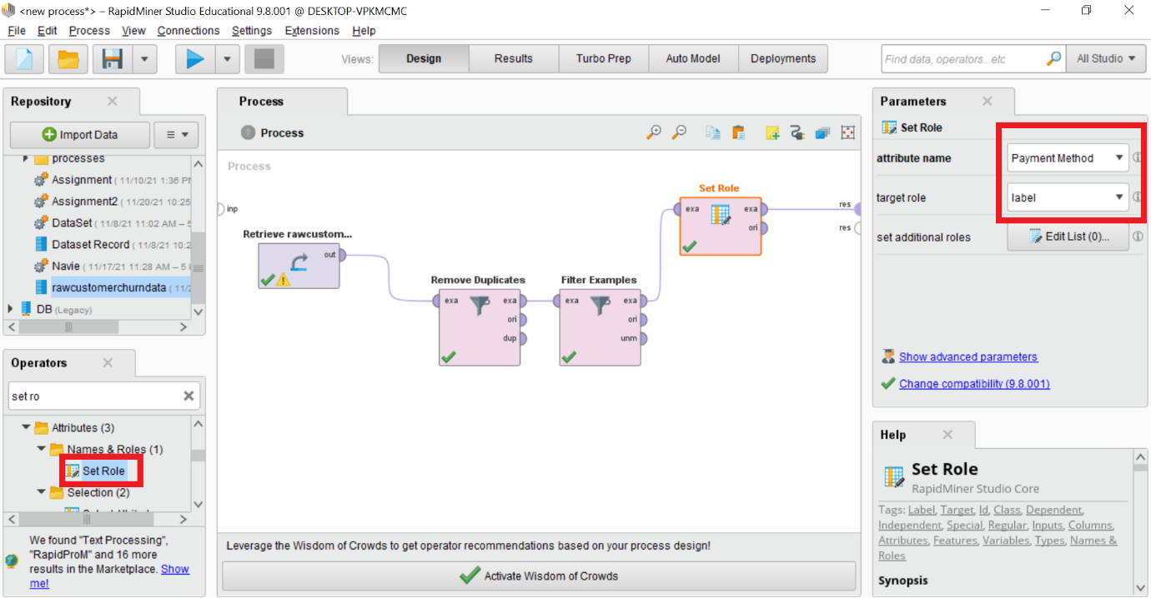

Output of set role operation. Payment method have different color showing different role between all attributes after perform the operation.

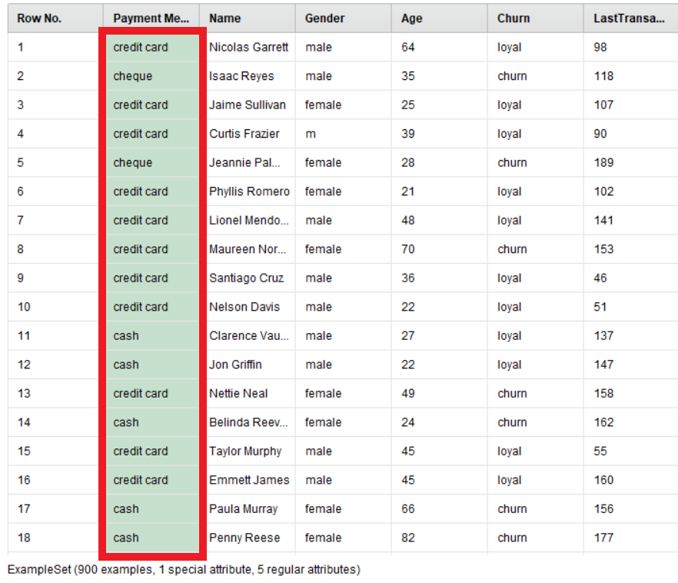

1. **Visualizing data using one of the graphs and bar charts.**

**Graphs**: When I execute the all operation then I go to the **Visualizations Button** then I select the **Graph** and see the visualizing data in **Graph** format.

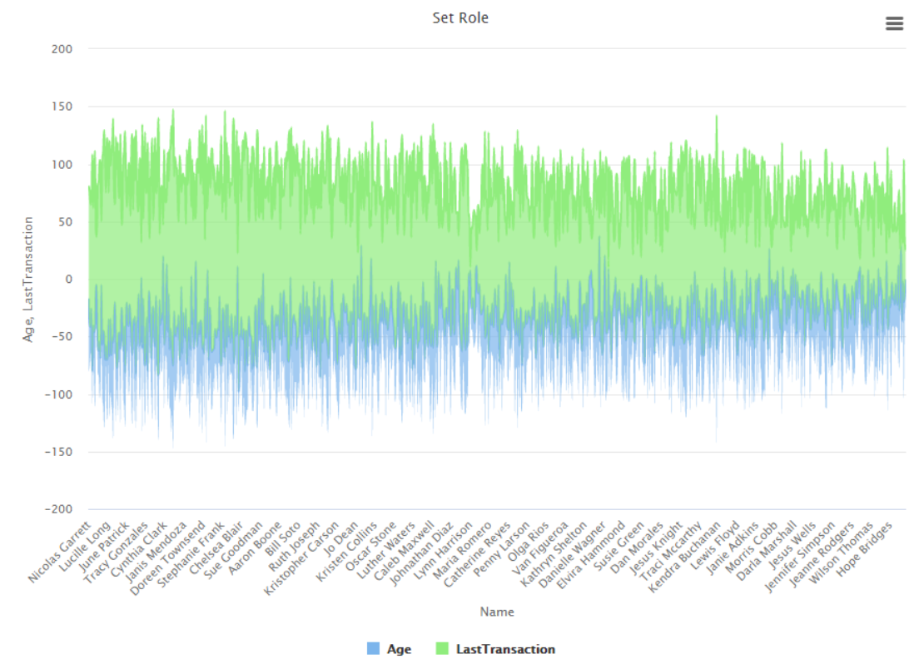

**Bar chart:**  I select the **Bar chart** and see the visualizing data in **Bar** format.

